

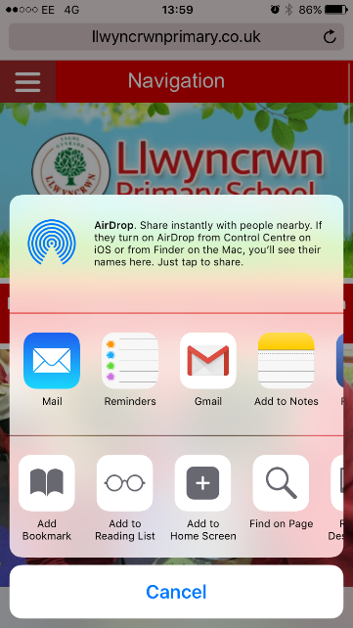
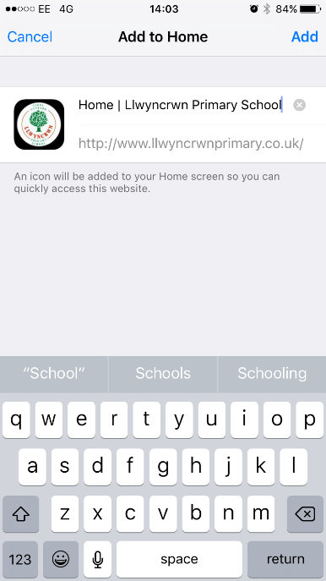
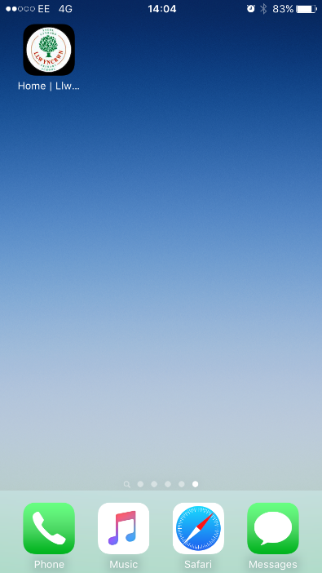
Step 1: Visit the school website on your mobile device
How to save the school website as an icon on your iPhone or iPad:
Step 2: Click on the link area to highlight
Step 3: Click the save page icon
Step 4: Click Add to home screen
Step 5: Click Add
Step 6: The icon will save to your home screen:

