How to save the school website icon to your home screen on an Android device:
Step 2: Click to expand options
Step 1: Visit the school website on your mobile device


Step 4: Click ‘Add’
Step 3: Select ‘Add to home screen’
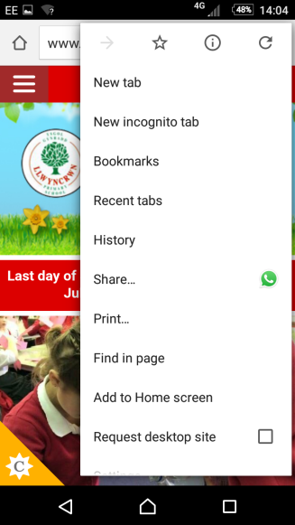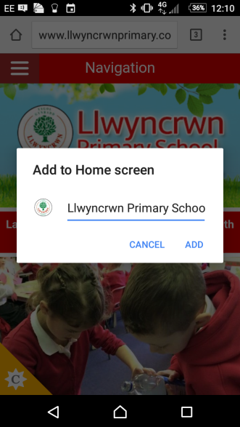
Step 5: The item will be added to your home screen
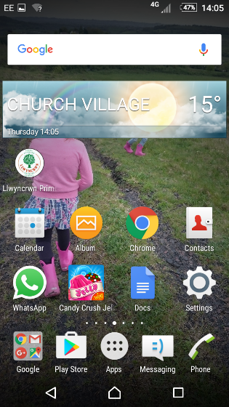
Step 5: The icon will appear on your screen

